FISH POND WATER MONITORING SYSTEM
Submitted By:
Subham Basak - 23BEC7119
Arkopaul Nandi – 23BEC7035
Sree Mansi Paupuleti – 23BEC7250
Raghav Priye Sharma – 23BCE8425
Pragalbh Telang – 23BCE7141
Nishant Chauhan – 23MIS7200
Under the Guidance of:
Dr. Chandan Nayak, Asst. Prof.
SENSE, VIT-AP University
Department of Electronics and Communication Engineering
Vellore Institute of Technology – Andhra Pradesh (VIT-AP University)

ABSTRACT
The Fish Pond Water Monitoring System is an IoT-based solution designed to continuously monitor critical water quality parameters such as temperature, pH, turbidity, and Total Dissolved Solids (TDS). The system uses an ESP32 microcontroller due to its built-in Wi-Fi capability, allowing real-time data transmission to the ThingSpeak cloud platform for visualization. The sensors capture live data, which is uploaded periodically, providing fish farmers with remote insights into water health. The system includes a buzzer that triggers an alert when the water temperature exceeds a predefined safe range. This cost-effective and scalable design helps automate aquaculture management, reduce manual effort, and enhance fish productivity.
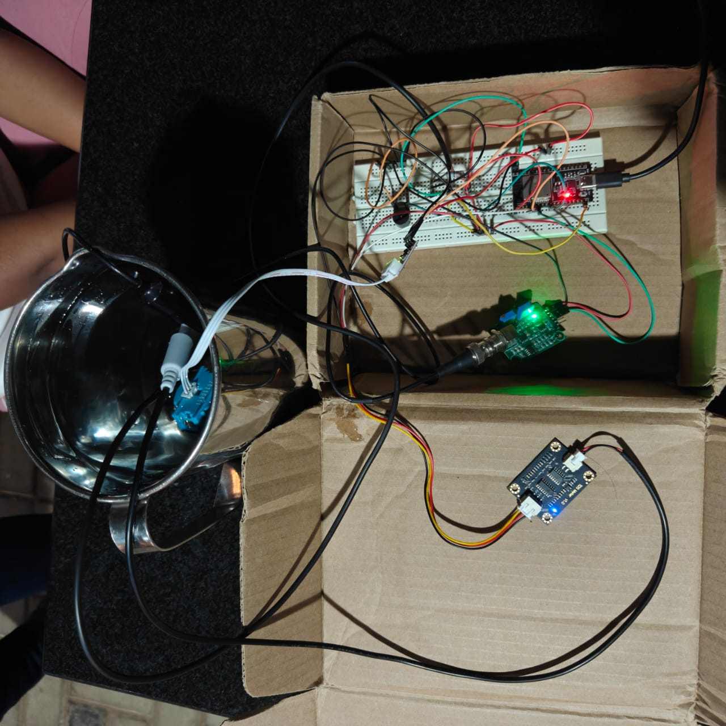
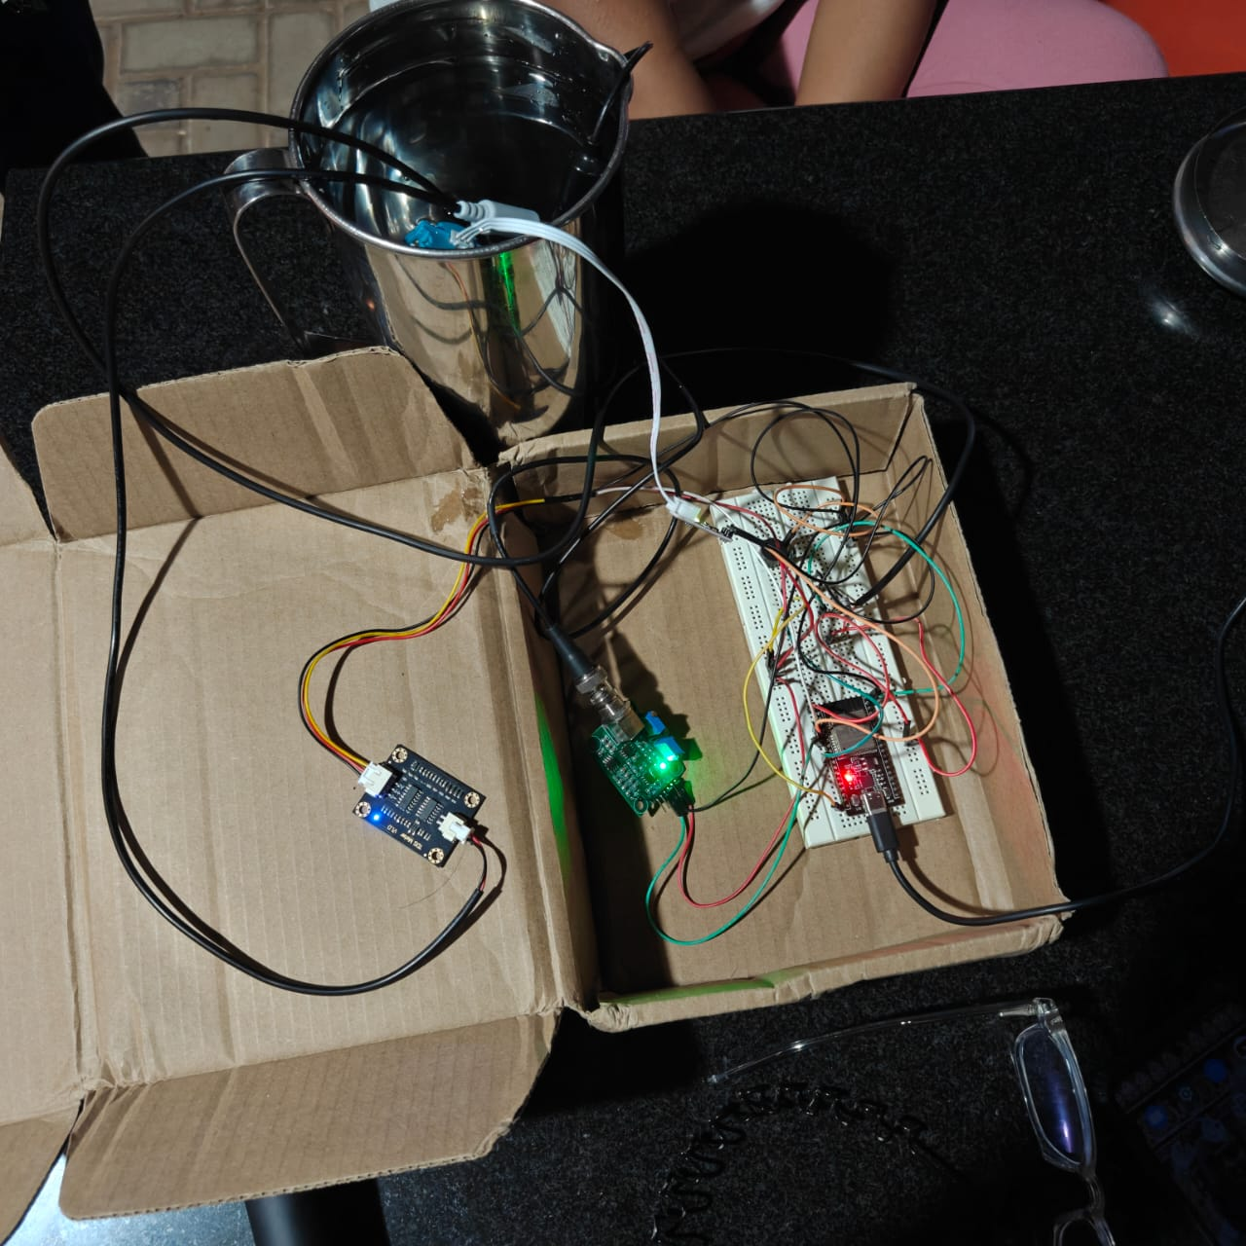

INDEX
Sl. No. | Content | Page No.
1 | Introduction | 4
2 | Background | 5
3 | Problem Definition | 6
4 | Objectives of the Proposed Work | 7
5 | Methodology / Procedure | 8-9
6 | Results and Discussion | 10
7 | Conclusion and Future Scope | 11
8 | References | 11
9 | Appendix – Codes | 12-13

1. INTRODUCTION
India is one of the world’s leading producers of freshwater fish, and sustainable aquaculture has become a key contributor to rural income. However, fluctuating pond conditions often cause disease outbreaks that drastically reduce yield.
Traditional water testing involves manual sampling and laboratory analysis that occur once every few days, which cannot capture sudden variations. A difference of only a few degrees in temperature or a small change in pH can make the environment unsuitable for many species.
With the rapid growth of the Internet of Things (IoT), it has become possible to connect inexpensive sensors and microcontrollers to the Internet for continuous monitoring. The Fish Pond Water Monitoring System leverages these advances by collecting live sensor data and uploading it automatically. Users can observe graphs and thresholds in real time from anywhere in the world using smartphones or laptops.
This automation not only reduces manual effort but also allows early detection of deteriorating water conditions, thereby improving productivity and sustainability.

2. BACKGROUND
The global aquaculture industry has been moving toward precision fish farming, where sensors, control systems, and analytics replace guesswork. The key physical and chemical parameters influencing fish health are:
- Temperature: Affects metabolic rate and dissolved oxygen levels.
- pH: Indicates acidity or alkalinity; most freshwater fish thrive between 6.5 – 8.5.
- Turbidity: Represents clarity of water and suspended particles that may block sunlight and hinder photosynthesis.
- TDS: Measures salts, minerals, and organic matter; excessive values indicate pollution or poor filtration.
Early electronic monitoring systems were expensive and non-networked. Recent progress in open-source hardware, cloud computing, and low-power Wi-Fi modules has made real-time water monitoring affordable for small farms.
Among available microcontrollers, ESP32 stands out for integrating dual-core processors, Bluetooth, and Wi-Fi on a single chip. Using this platform, environmental data can be captured, processed locally, and uploaded to the ThingSpeak IoT platform — a free service by MathWorks that allows online storage and visualization of sensor data.

3. PROBLEM DEFINITION
The management of fish ponds relies heavily on maintaining proper water quality, as even small fluctuations in parameters such as temperature, pH, turbidity, and Total Dissolved Solids (TDS) can significantly affect fish health, metabolism, and breeding efficiency. Such methods fail to provide real-time insights, which means that any deviation in water conditions might go unnoticed until it is too late, potentially leading to fish stress, disease outbreaks, or even mass mortality.
In addition, most existing commercial water monitoring systems are expensive and come as closed-source products, offering limited customization or scalability. They are often designed for large-scale industrial use, making them unsuitable for small or medium-scale fish farms that operate on limited budgets. Furthermore, these systems frequently lack automated alert mechanisms or cloud integration features, requiring the user to be physically present at the site for data collection and interpretation. This limits their practicality and accessibility for remote or rural aquaculture applications.
Given these limitations, there is a strong demand for a low-cost, automated, and wireless monitoring solution that can address the following critical needs:
- Continuous and Real-Time Monitoring:
The system must be capable of continuously measuring key water-quality parameters such as temperature, pH, turbidity, and TDS without requiring constant human intervention. Continuous data collection ensures that any changes in pond conditions are detected instantly.
- Data Logging and Visualization:
The readings should be stored and visualized on a cloud-based platform to provide long-term analysis and trend observation. Visualization helps farmers or researchers understand environmental patterns and predict possible threats to aquatic life.
- Automated Alert Mechanism:
The system should include an alert or alarm system (e.g., a buzzer or notification via cloud platform) that immediately warns the user when any parameter exceeds safe operational limits, enabling timely corrective actions to prevent harm.
- Scalability and Affordability:
The proposed solution should be scalable to cover multiple ponds and adaptable to different environments, while remaining affordable and easy to maintain.

OBJECTIVES OF THE PROPOSED WORK

- Design a modular IoT framework for continuous environmental monitoring of aquaculture ponds.
- Integrate ESP32 with multiple analog and digital sensors to acquire accurate readings.
- Establish wireless connectivity to ThingSpeak for live data storage and graphical analysis.
- Develop a local alert mechanism using a buzzer to warn against temperature extremes.
- Validate the system through field testing and analyze results for consistency and reliability.
- Provide scalability and cost efficiency, enabling replication across multiple ponds or different aquatic species.

5. METHODOLOGY / PROCEDURE

5.1 System Architecture
The overall structure consists of:
- Sensor Unit: Comprising the DS18B20 temperature sensor, pH probe, TDS sensor, and turbidity sensor.
- Controller Unit: ESP32 Dev Board handling data acquisition, processing, and communication.
- Communication Module: Built-in Wi-Fi of ESP32 for Internet connectivity.
- Alert System: Buzzer triggered on threshold breach.
- Cloud Platform: ThingSpeak API channel for storage and visualization.
(Insert Figure – Block Diagram here)
5.2 Hardware Description
Component | Function
ESP32 | Central controller with dual-core CPU, ADC channels, Wi-Fi, Bluetooth.
DS18B20 Sensor | Measures temperature digitally with 12-bit accuracy.
pH Sensor Module | Analog sensor producing voltage proportional to acidity/alkalinity.
TDS Sensor | Determines concentration of dissolved ions and solids.
Turbidity Sensor | Uses infrared light scattering to gauge water clarity.
Buzzer | Audio indicator for temperature-based alerts.
Resistors (3.3 k–10 k Ω) | Used as pull-up resistors for signal stabilization.

5.3 Software Tools
- Arduino IDE for coding and firmware upload.
- ThingSpeak Cloud for IoT data management.
- Serial Monitor for debugging and calibration.
5.4 Working Principle
- Sensors generate analog or digital outputs representing physical parameters.
- The ESP32 reads these signals via its ADC pins, converts them into calibrated engineering units, and formats them as JSON strings.
- The controller connects to Wi-Fi using SSID and password credentials, then periodically sends HTTP POST requests to ThingSpeak.
- ThingSpeak stores the data in separate fields and plots real-time graphs accessible through any web browser.
- The buzzer is activated if temperature exceeds the threshold (for example > 32 °C), signaling the farmer to take corrective action.
(Insert Figure – Circuit Diagram here)
5.5 Flow Chart
- Start → Initialize Wi-Fi → Read Sensors → Display/Upload → Check Thresholds → Activate Buzzer (if needed) → Delay → Repeat.

6. RESULTS AND DISCUSSION
After assembling and calibrating the sensors, tests were performed on a 25-liter container simulating pond water. The system uploaded data every 30 seconds to the ThingSpeak channel.

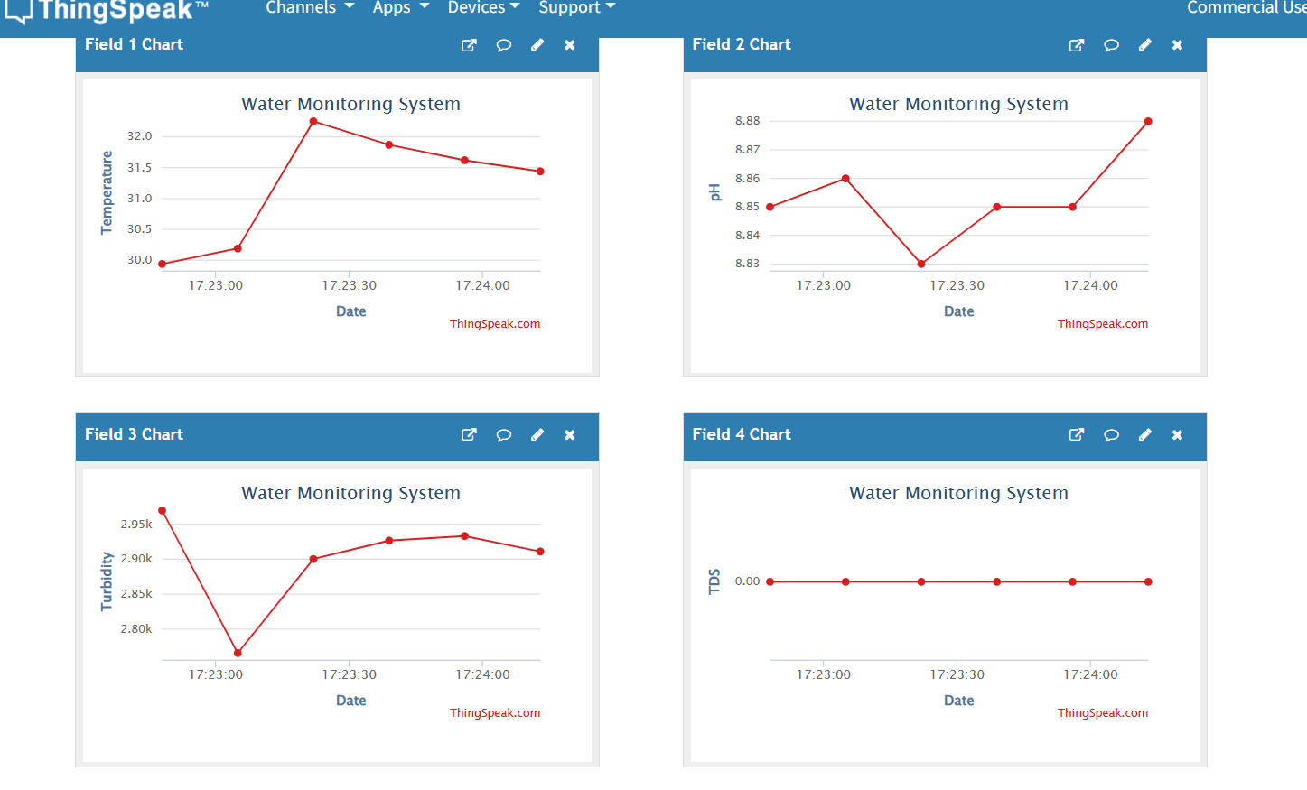
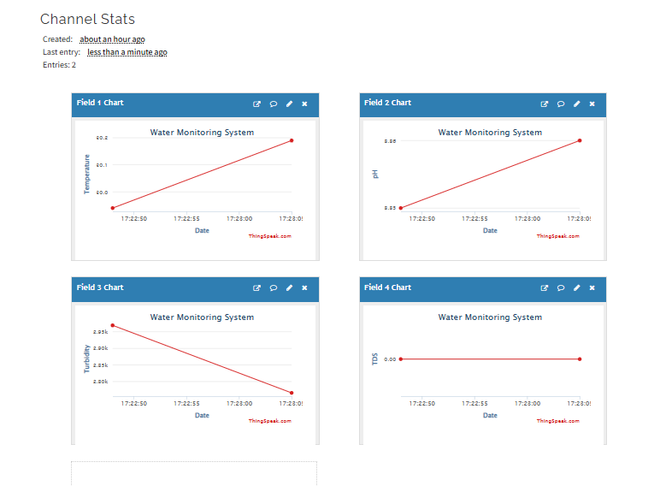

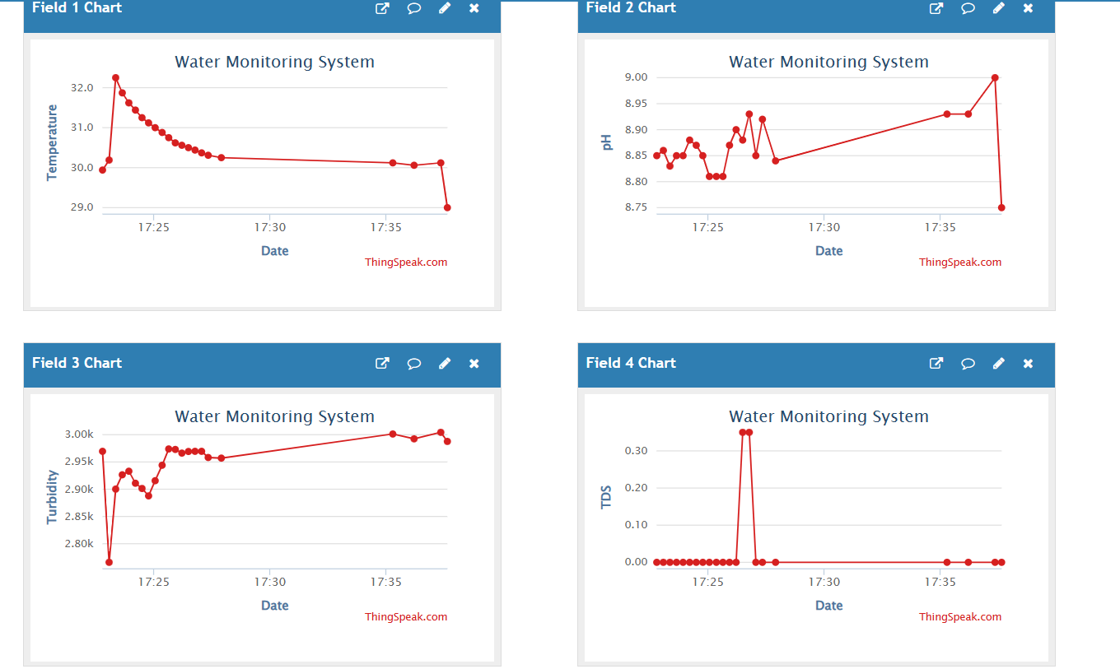

7. CONCLUSION AND FUTURE SCOPE
Conclusion
The developed Fish Pond Water Monitoring System successfully integrates environmental sensors with an IoT framework, providing accurate, real-time water-quality analysis. Continuous monitoring allows early corrective actions, reducing fish mortality and increasing productivity.
The project demonstrates that a compact, microcontroller-based solution can replace expensive laboratory equipment for many practical aquaculture scenarios.
Future Scope
- Automated Control: Couple the system with aerators or feeders that operate automatically when thresholds are reached.
- Mobile Application: Develop a cross-platform app for instant push notifications.
- Solar Power Integration: Ensure energy self-sufficiency for rural installations.
- Data Analytics: Apply machine-learning algorithms on historical data to predict environmental trends.
- Scalability: Extend monitoring to multiple ponds using a single gateway node and LoRa communication.

8. REFERENCES
1. Espressif Systems, 'ESP32 Technical Reference Manual', 2023.
2. Dallas Semiconductor, 'DS18B20 Digital Thermometer Datasheet', 2022.
3. MathWorks, 'ThingSpeak IoT Platform Documentation', 2024.
4. R. Sahu et al., 'IoT-Based Aquaculture Monitoring System', IEEE Sensors Journal, 2023.

9. APPENDIX – CODES
The source code below demonstrates how ESP32 reads multiple sensors and transmits data to ThingSpeak.
#include <Arduino.h>
#include <OneWire.h>
#include <DallasTemperature.h>
#include <WiFi.h>
#include <HTTPClient.h>
#define TEMP_PIN 4
#define PH_PIN 34
#define TDS_PIN 35
#define TURB_PIN 32
#define BUZZER 25
#define TEMP_THRESHOLD 32.0
const char* ssid = "YourWiFi";
const char* password = "YourPassword";
const char* server = "https://api.thingspeak.com/update?api_key=YOUR_API_KEY";
OneWire oneWire(TEMP_PIN);
DallasTemperature sensors(&oneWire);
void setup() {
Serial.begin(115200);
sensors.begin();
pinMode(BUZZER, OUTPUT);
WiFi.begin(ssid, password);
while (WiFi.status() != WL_CONNECTED) {
delay(500);
Serial.print(".");
}
Serial.println("Connected to WiFi");
}
void loop() {
sensors.requestTemperatures();
float tempC = sensors.getTempCByIndex(0);
int phVal = analogRead(PH_PIN);
int tdsVal = analogRead(TDS_PIN);
int turbVal = analogRead(TURB_PIN);
if (tempC > TEMP_THRESHOLD) digitalWrite(BUZZER, HIGH);
else digitalWrite(BUZZER, LOW);
if (WiFi.status() == WL_CONNECTED) {
HTTPClient http;
String url = String(server) + "&field1=" + String(tempC) + "&field2=" + String(phVal) + "&field3=" + String(tdsVal) + "&field4=" + String(turbVal);
http.begin(url);
http.GET();
http.end();
}
delay(15000);
}

